**KubeAI: Smart Remediation, Seamless Clusters**

**Problem Statement**

Kubernetes clusters are widely used for containerized application deployment, but they frequently face pod failures, resource exhaustion, and network issues, leading to system instability and downtime. Traditional monitoring tools provide alerts but lack predictive intelligence and automated remediation, requiring manual intervention by administrators.

This project aims to **leverage AI/ML** to proactively **predict failures** and recommend **intelligent remediation strategies**. The system will feature:

* **Real-Time Health Dashboard** displaying live cluster status, alerts, and failure predictions.
* **Manual Approval for Fixes**, allowing admins to review AI-suggested actions before execution.
* **Automated Log Analysis** to correlate system logs and identify root causes of failures.
* **Self-Healing Recommendations** that suggest optimal recovery actions like scaling pods or restarting nodes.
* **Anomaly Severity Scoring** to classify issues into **Low, Medium, or High priority**, aiding decision-making.
* **Predictive Insights & Reports** that analyze historical trends for proactive system optimization.

By integrating AI-driven failure prediction, intelligent remediation, and a user-friendly monitoring interface, this solution enhances Kubernetes clusterresilience, minimizes downtime, and optimizes resource allocation, ensuring a self-healing and efficient container orchestration environment.

**Advantages**

1. **Enhanced Cluster Reliability**

* Predicts failures before they occur, preventing unexpected downtime.
* Improves system resilience with intelligent remediation strategies.

2. **Reduced Downtime & Faster Recovery**

* Automated self-healing recommendations speed up failure resolution.
* AI-based insights help administrators act before critical failures escalate.

3. **Proactive Monitoring & Predictive Insights**

* Real-time health dashboard provides a clear view of cluster performance.
* Historical trend analysis helps optimize resource allocation.

4. **AI-Driven Decision Making**

* Anomaly severity scoring classifies issues by priority (Low, Medium, High).
* Automated log analysis correlates failures with root causes for better troubleshooting.

5. **Optimized Resource Utilization**

* Dynamically scales pods and reassigns resources based on predictions.
* Prevents resource exhaustion by proactively managing workloads.

6. **Improved Security & Stability**

* Detects and mitigates potential security vulnerabilities in clusters.
* Reduces human errors by automating repetitive remediation tasks.

7. **User-Centric Flexibility**

* Allows manual approval for fixes, giving administrators control over AI-suggested actions.
* Customizable remediation strategies to fit different Kubernetes environments.

8. **Lower Operational Costs**

* Reduces the need for manual troubleshooting, saving admin time and effort.
* Prevents unnecessary infrastructure scaling, optimizing cloud costs.

9. **Scalable & Cloud-Ready**

* Easily deployable across AWS EKS, GKE, Azure AKS, and on-premise clusters.
* Supports integration with existing Kubernetes monitoring tools like Prometheus and ELK Stack.

This solution transforms Kubernetes cluster management into an autonomous, resilient, and cost-efficient system through AI-powered predictive analytics, intelligent remediation, and a user-friendly interface.

**Challenges Faced**

* **Data Availability & Quality** – Limited labeled datasets for training AI models.
* **Real-Time Processing** – Ensuring low-latency failure predictions and remediation.
* **Model Accuracy & False Positives** – Balancing precision to avoid unnecessary remediations.
* **Integration with Existing Kubernetes Setups** – Adapting to different cluster configurations.
* **Security & Access Control** – Ensuring AI-driven actions do not compromise cluster security.
* **Scalability** – Handling large-scale Kubernetes clusters with thousands of nodes.
* **Interpreting Log Data** – Extracting meaningful insights from diverse log formats.
* **Human Oversight vs. Automation** – Deciding when to automate vs. requiring manual approval.
* **Cost Overheads** – Managing computing resources efficiently to avoid excessive expenses.

**Technologies Used**

**Programming & AI/ML**

* **Python** – Primary language for AI/ML and backend logic.
* **TensorFlow & Scikit-Learn** – Machine learning model training and prediction.

**Kubernetes & Orchestration**

* **Kubernetes API (client-python)** – Interacting with the cluster for monitoring and remediation.
* **Minikube** – Local Kubernetes cluster for testing and development.
* **Helm** – Managing Kubernetes applications with package deployment.

**Logging & Monitoring**

* **Prometheus** – Collecting real-time metrics from Kubernetes clusters.
* **Fluentd** – Aggregating and processing logs for AI model training.
* **ELK Stack (Elasticsearch, Logstash, Kibana)** – Advanced log storage, analysis, and visualization.

**Remediation & Automation**

* **Kubernetes Operators** – Automating management of cluster components.
* **Terraform** – Infrastructure as Code (IaC) for provisioning Kubernetes environments.
* **Ansible** – Automating cluster configuration and remediation actions.

**Frontend & Visualization**

* **ReactJS** – Web interface for real-time dashboard and user interactions.
* **D3.js / Chart.js** – Visualizing cluster health, alerts, and failure predictions.

**Deployment & Containerization**

* **Docker** – Packaging and deploying AI models and Kubernetes components.
* **AWS EKS / GKE / Azure AKS** – Cloud deployment options for production environments.

**Security & Access Control**

* **Role-Based Access Control (RBAC)** – Managing permissions for AI-driven actions.
* **Vault by HashiCorp** – Securely managing sensitive Kubernetes credentials.

**Code and Output**

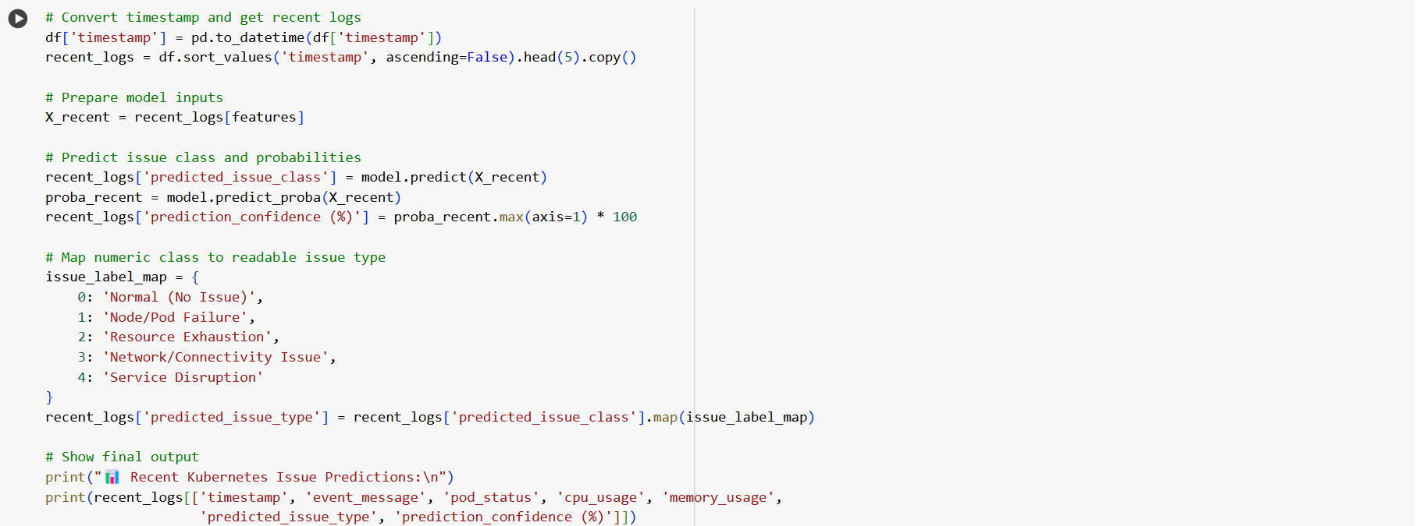

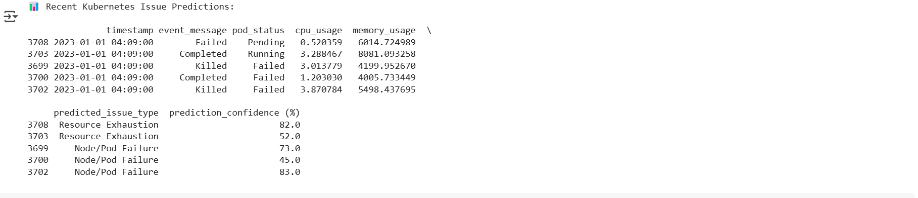

**Architecture Diagram**

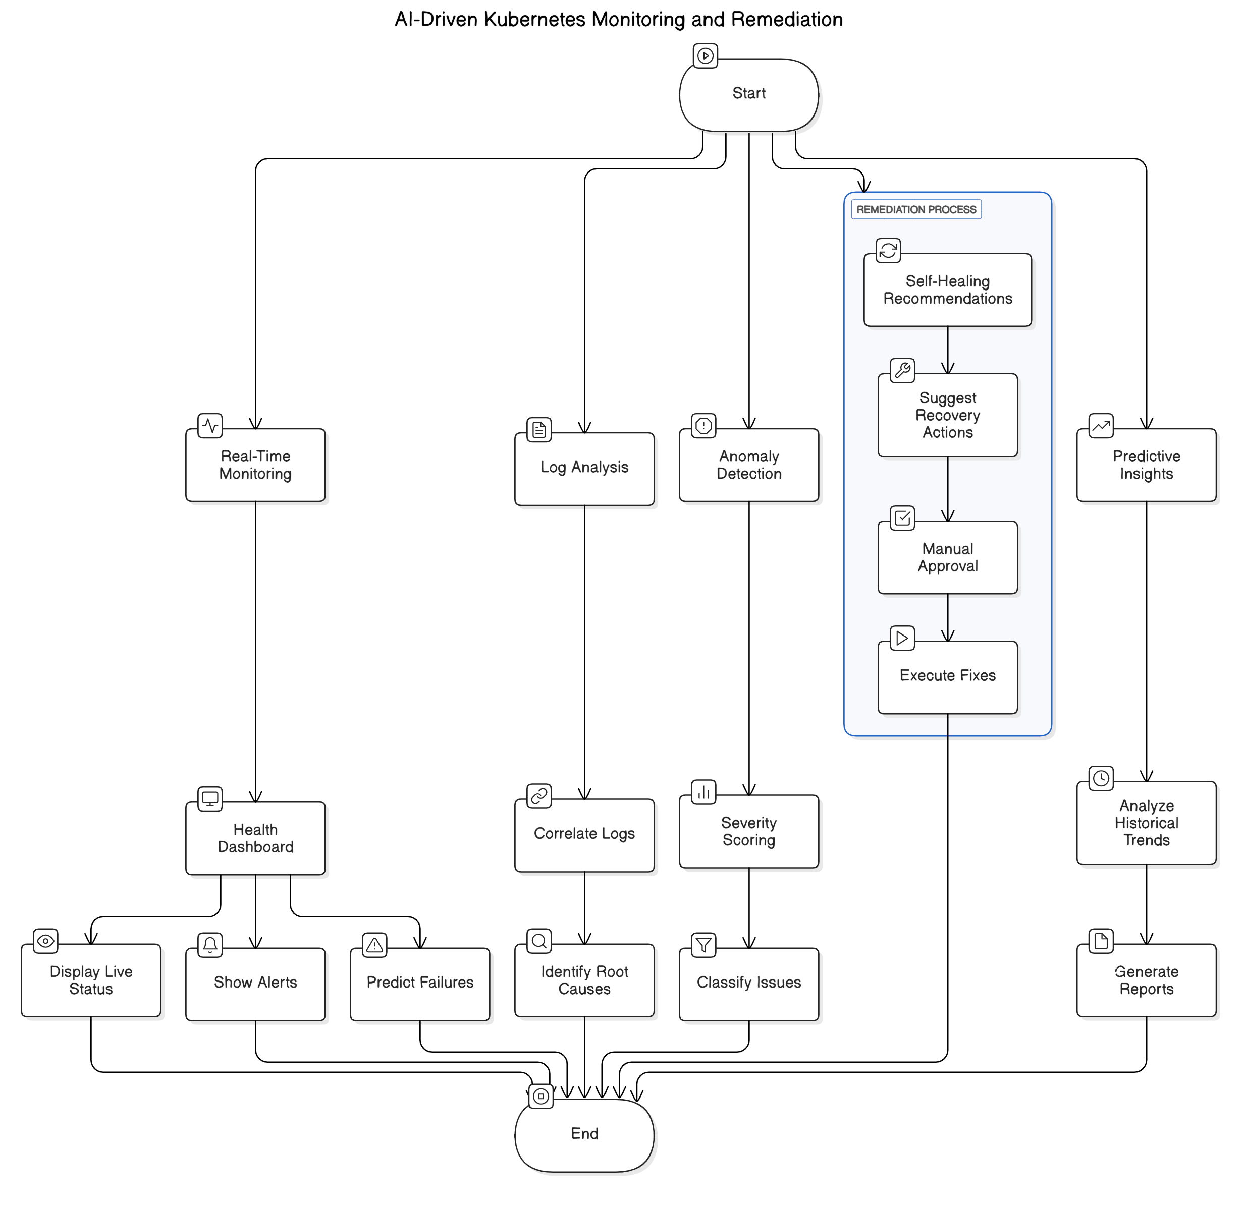

**Dataset Used:**

The Kubernetes Resource and Performance Metrics Allocation dataset from Kaggle contains detailed information on resource usage and allocation within a Kubernetes cluster. It includes key metrics such as CPU and memory requests, limits, usage, node allocations, and pod performance over time. This dataset is useful for analyzing workload efficiency, identifying performance bottlenecks, and detecting anomalies in resource consumption. By merging this dataset, we have created a more comprehensive version that consolidates relevant metrics, enabling better insights into Kubernetes performance trends and facilitating improved decision-making for resource optimization.